Final Results
- Variant 1 (Frozen backbone)
  - Training accuracy (final epoch): = 68.6%
  - Validation accuracy (final epoch): = 68.6%
- Variant 2 (Partially frozen backbone)
  - Training accuracy (final epoch): = 93.9%
  - Validation accuracy (final epoch): = 93.9%
- Variant 3 (Fully trainable model)
  - Training accuracy (final epoch): = 98.0%
  - Validation accuracy (final epoch): = 98.0%

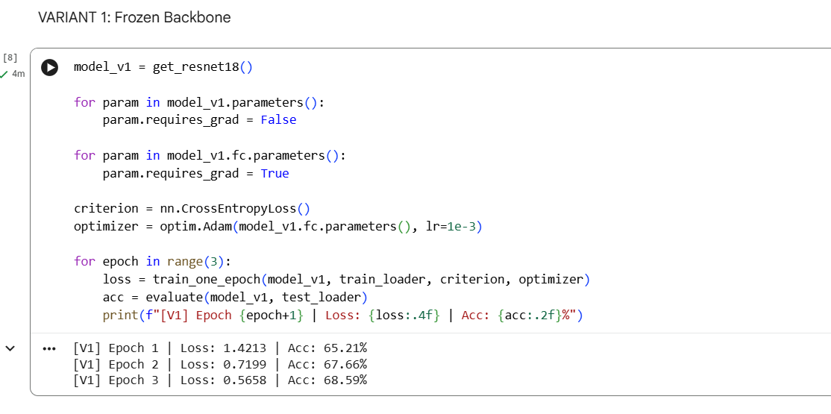

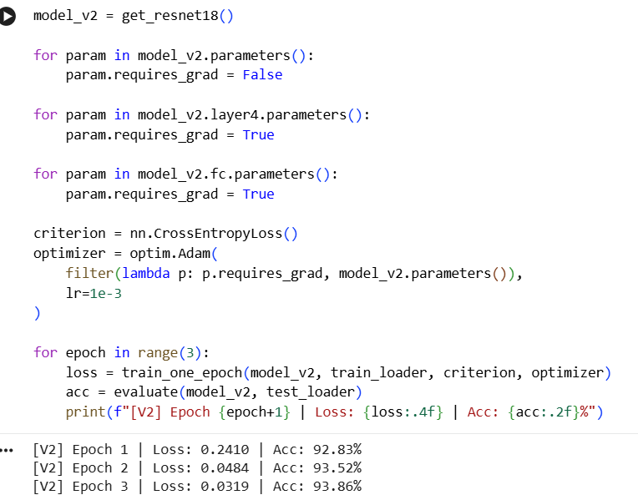
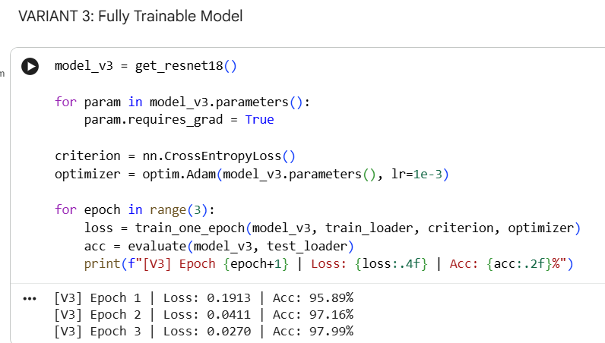

Which variant converged fastest? Why?
Variant 1 (Frozen backbone) converged the fastest in terms of optimization stability because only the final classification layer was trained, resulting in very few trainable parameters and a simpler optimization problem. Since the pretrained backbone already provides meaningful generic features, the classifier quickly adapts to the new task without needing to adjust deep representations.
Which variant showed the most overfitting?
Variant 3 (Fully trainable model) showed the highest risk of overfitting. Although it achieved the highest training and validation accuracy within a few epochs, fully fine-tuning all layers introduces a large number of trainable parameters relative to the dataset size, allowing the model to potentially memorize dataset-specific patterns rather than relying on generalizable features.
Why does freezing early layers often work well for MNIST?
Freezing early layers works well for MNIST because early convolutional layers learn generic visual features such as edges, corners, and simple textures, which are common across many vision tasks. MNIST is a simple and small dataset with high task similarity to ImageNet’s low-level features, so retraining these early layers is unnecessary and can even degrade performance due to overfitting.
In what situation would full fine-tuning be necessary?
Full fine-tuning becomes necessary when the target task is very different from the pretraining task or when the dataset is large and diverse enough to support learning new feature representations. Examples include medical imaging, satellite imagery, or domain-specific data where ImageNet features are not sufficiently relevant, and where the dataset size is large enough to prevent overfitting.

